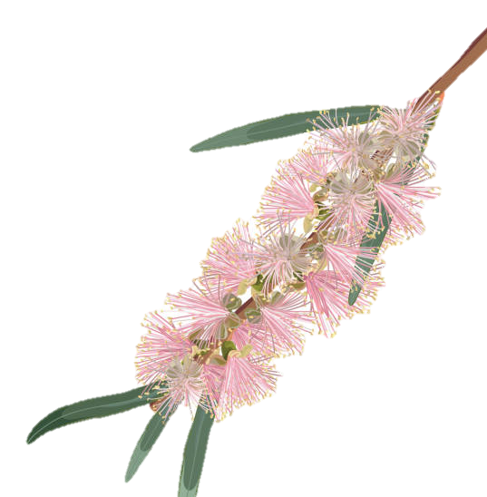

Leeton Show Society

My Plan Connect Young Woman Competition 2023

Dear Entrant,
Thank you for considering a place in our young woman competition at the Leeton Show. The Young Woman Competition gives you the opportunity to meet new people, learn new skills and demonstrate your ability to promote yourself and your town to others. It is an opportunity to learn more about yourself, your community, and improve your interview and public speaking skills. All whilst being supported by the Young Woman Competition committee and Leeton Show Society, and having fun along the way.
The Competition’s main sponsor is My Plan Connect and is open to girls between 18 and 26 years of age, married or single, and aims to find an ambassador for the Leeton Shire who will represent Leeton Show Society and Shire at a Zone Final in 2024. The winner and other entrants will receive a gift or prize on announcement night and a Personal Development weekend from Leeton Show Society for the winner in preparation for the zone final.
Enclosed is information about the Young Woman Competition, judging times, prizes and an entry form.
What to do:
- Read form A and sign and date
- Complete the entry form
- Attach your Resume
Return these three items to Janne Skewes, Leeton Show Society secretary via email: secretary@leetonshow.com
Judging will take place at one event on Saturday 23rd September 2023 which will be in the form of a formal sit-down interview followed by a meal and then a short tell us about yourself/ interview in front of all guests. At this event you will be interviewed by a judging panel which will consist of 3 judges. The judging guidelines are included on the information sheet. Then we will have a meal where you will be judged on etiquette, table manners and also ability to converse with the guests. We will then interview each girl in front of all guests on chosen questions by you, this will just be a little get to know you session and also will be a judge on your public speaking. The dress code for the dinner is smart day wear, which would be either a skirt and jacket/top or suit.
Once entry has been received, we will contact you with your judging time. If you have any queries, please don’t hesitate to contact any of the Leeton Show Young Woman Competition Committee.

Entry form

Surname: _________________________ First name: ____________________________
Date of birth: ______________________
Home Address: ____________________________________________________________________
___________________________________________________ Post code: _____________
Home Phone Number: ________________________
Mobile: _________________________ Email: ____________________________________________
What are your hobbies/Interests? __________________________________________________________________________________
__________________________________________________________________________________
__________________________________________________________________________________
__________________________________________________________________________________
__________________________________________________________________________________
__________________________________________________________________________________
What do you think you will get out of entering and participating in the competition? __________________________________________________________________________________
__________________________________________________________________________________
__________________________________________________________________________________
__________________________________________________________________________________
__________________________________________________________________________________
__________________________________________________________________________________
Resume enclosed [ ] (tick)
Declaration: I have read the rules of the competition and agree to abide by them
Signature: _______________________________________ Date: _________________
Closing date Friday 22nd September 2023

Information sheet

Any information on deportment, dress code, public speaking and the competition will be
available for you at any time via the Leeton Show Young Women Committee;
- Janne Skewes 0411893272 secretary@leetonshow.com
- Liz Munn 0477429761
- Anne Lepper
- Jenny Lashbrook

Judging – Interview & Luncheon– Saturday 23rd September 2023
Entrants will be judged on personality, confidence, ambition and life goals, general knowledge, knowledge of Leeton and rural affairs, presentation and speech. Dress code is Corporate Day wear.

Show opening – Friday 7th October 2023 & Show day – Saturday 8th October 2023
Dress code is smart day wear, which would be either a skirt and jacket/top or suit. The winner will be announced at the official opening of the Leeton Show 2023.

All entrants are asked to be available on Saturday 8th October at the Leeton Show to assist with the judging and running of the junior show girls & boys and also presentation of ribbons at various show events.

The winner of the Leeton Show My Plan Connect Young Woman Competition will participate in the Zone Final in 2024, and if successful there will then head to the Sydney Royal Easter Show to compete for Leeton in the state competition.

